# **Project Deliverable 4-**

**Group 11**

1. Rishi Vamshi Athinarap
2. Venkata Sai Shalini Ganni
3. Siva Naga Rutwik Reddy Chintha
4. Darshini Chalumuri

Setting up and creating Training JOB –

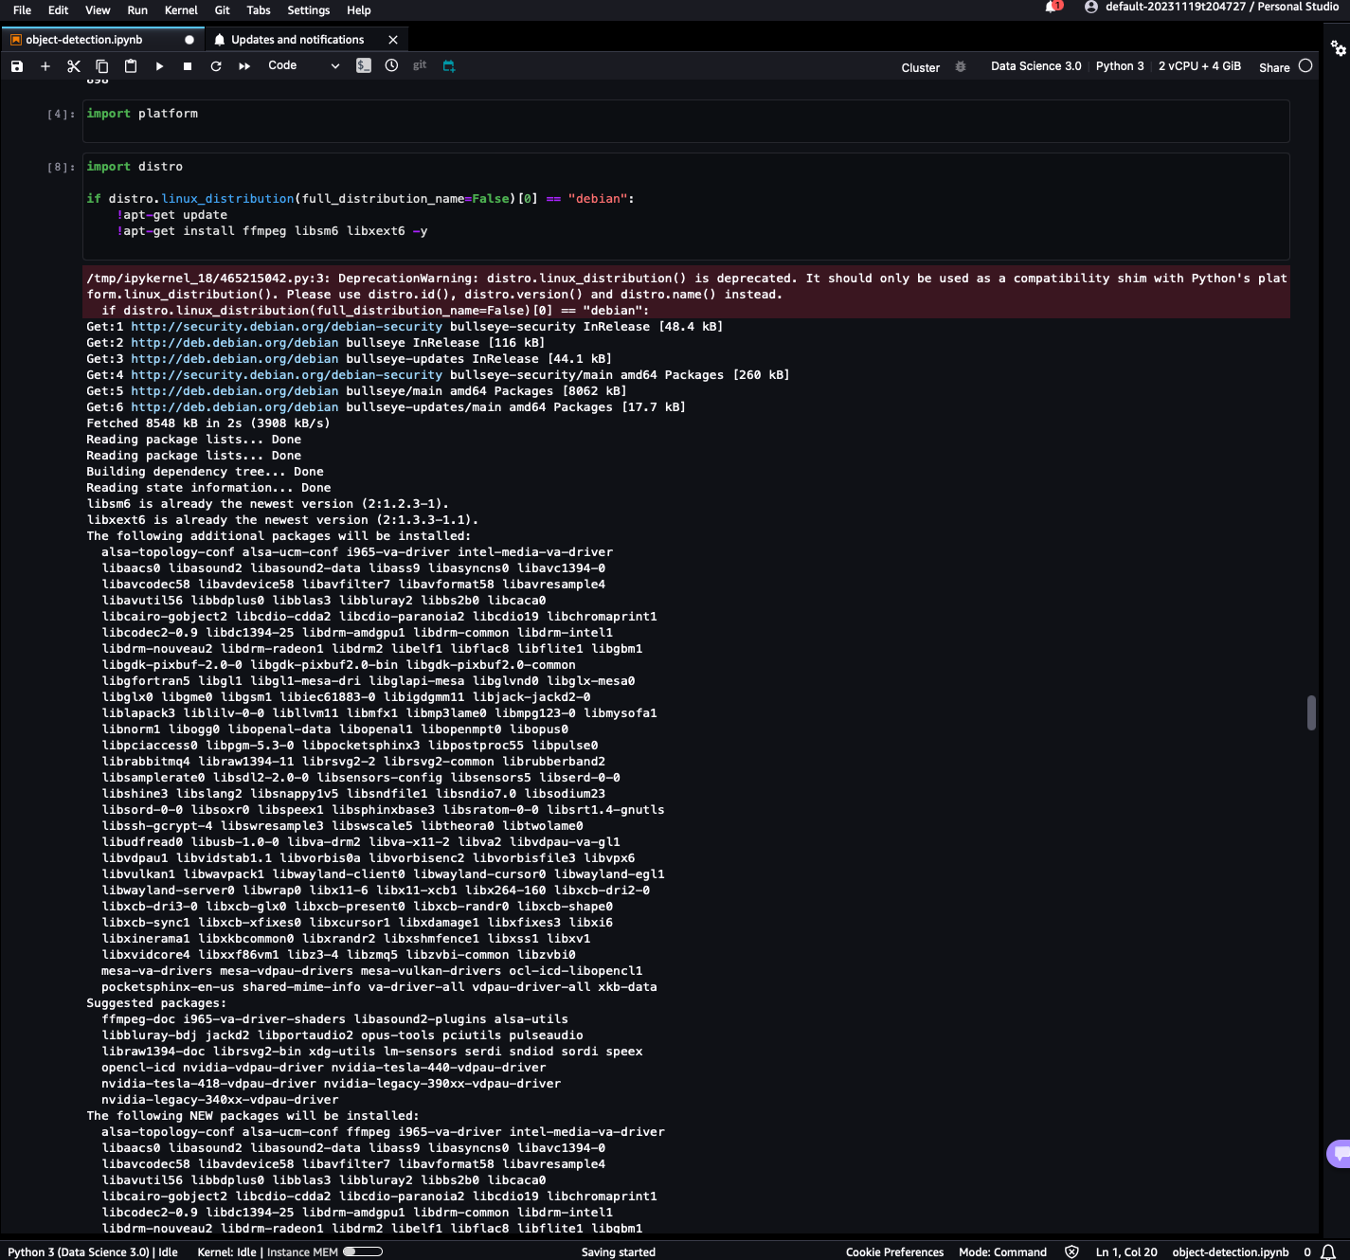

Creating RecordIO Files –

Utilized imrec2.py to create rec files.

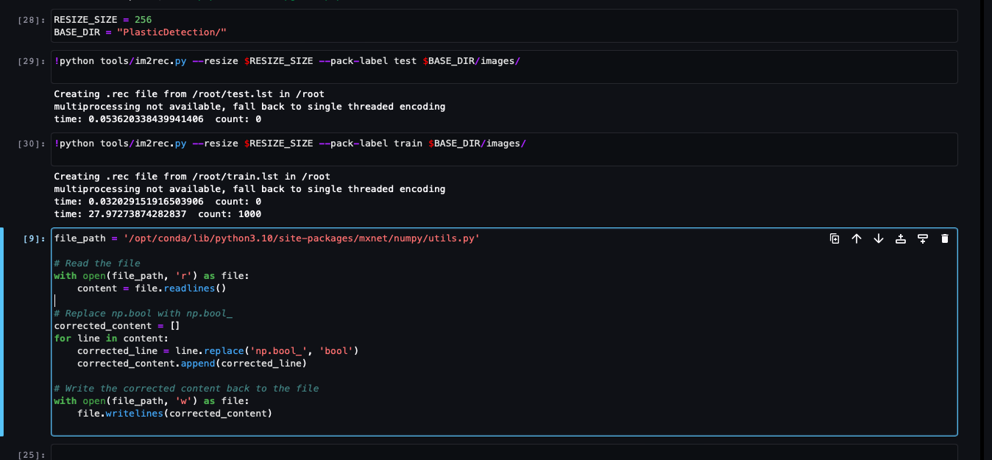

Uploading rec files to S3 bucket –

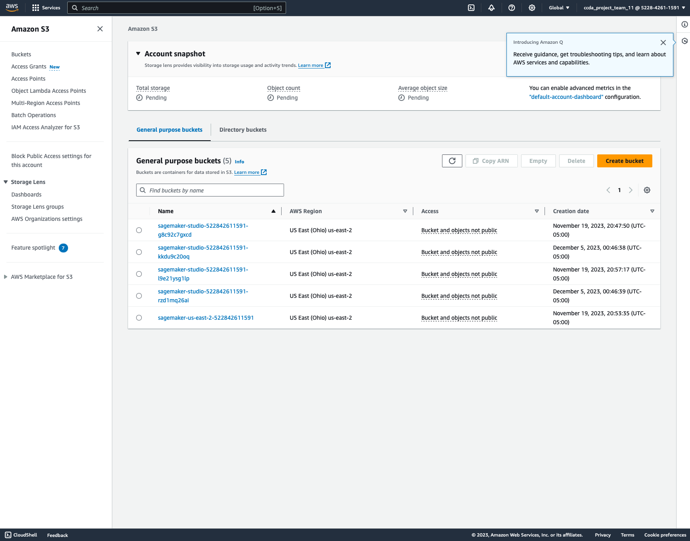

Created the S3 bucket –



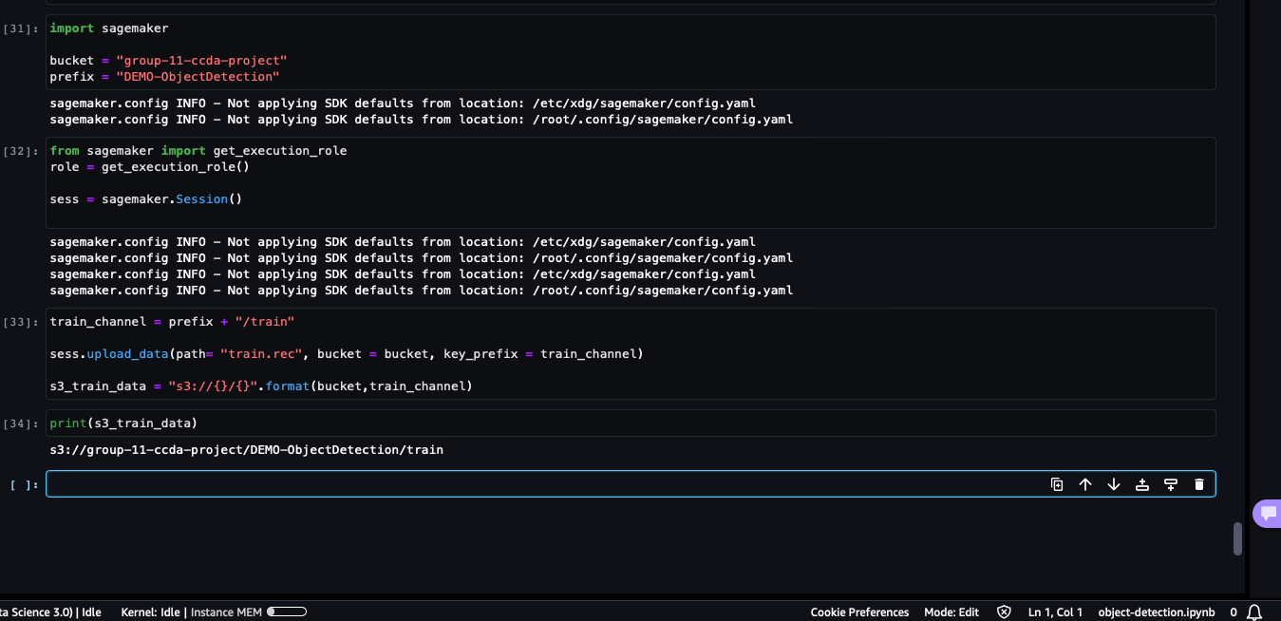

Rec files successfully uploaded to S3 -   
  
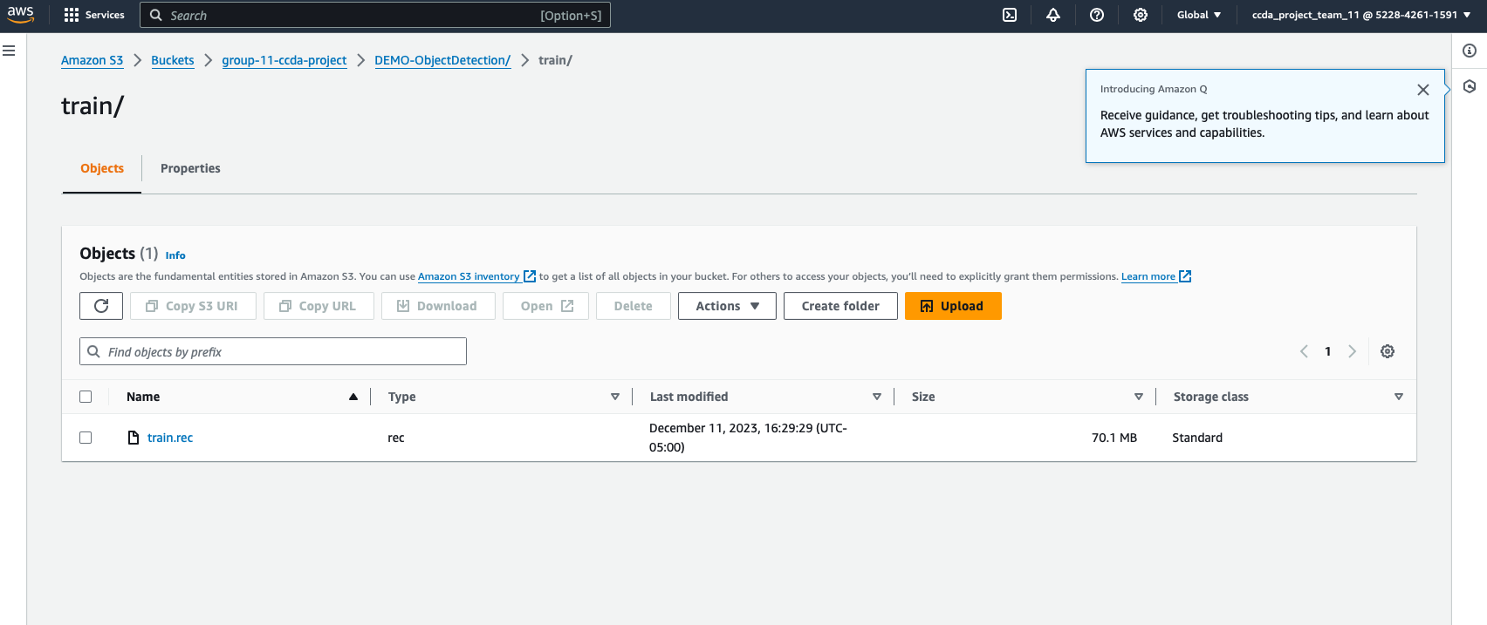

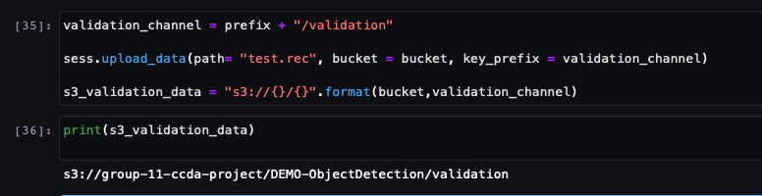

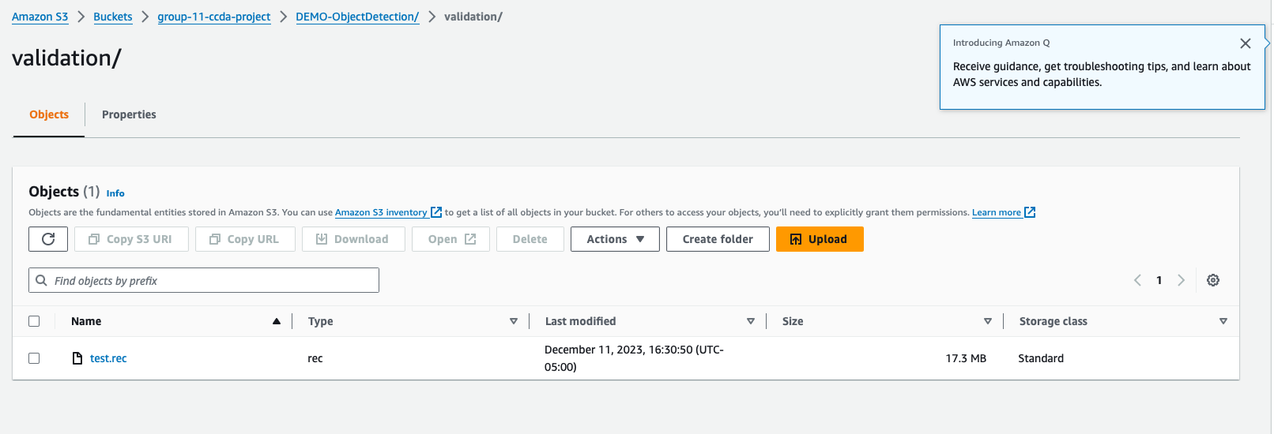

Download object detection algorithm from AWS ECR – (Elastic Container Registry)

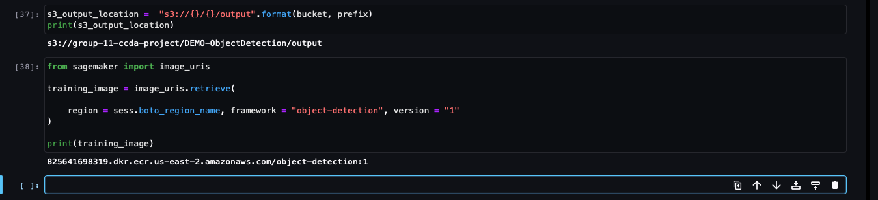

Setting up estimator model –

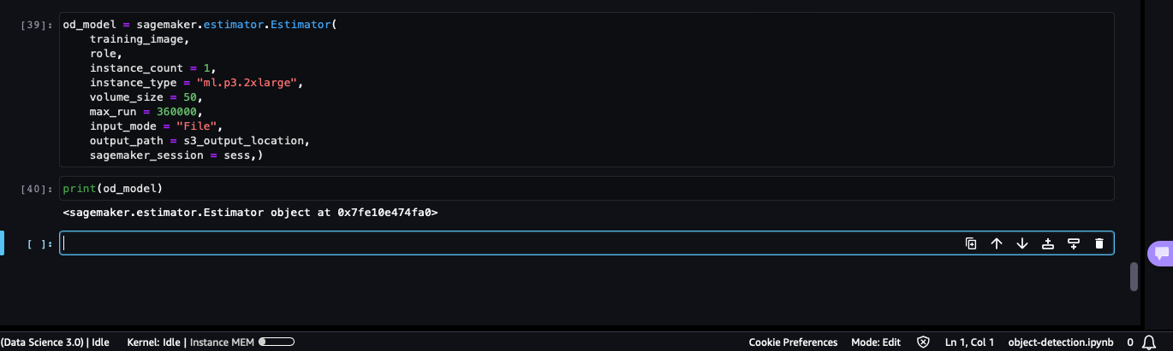

Set up Hyperparameters –

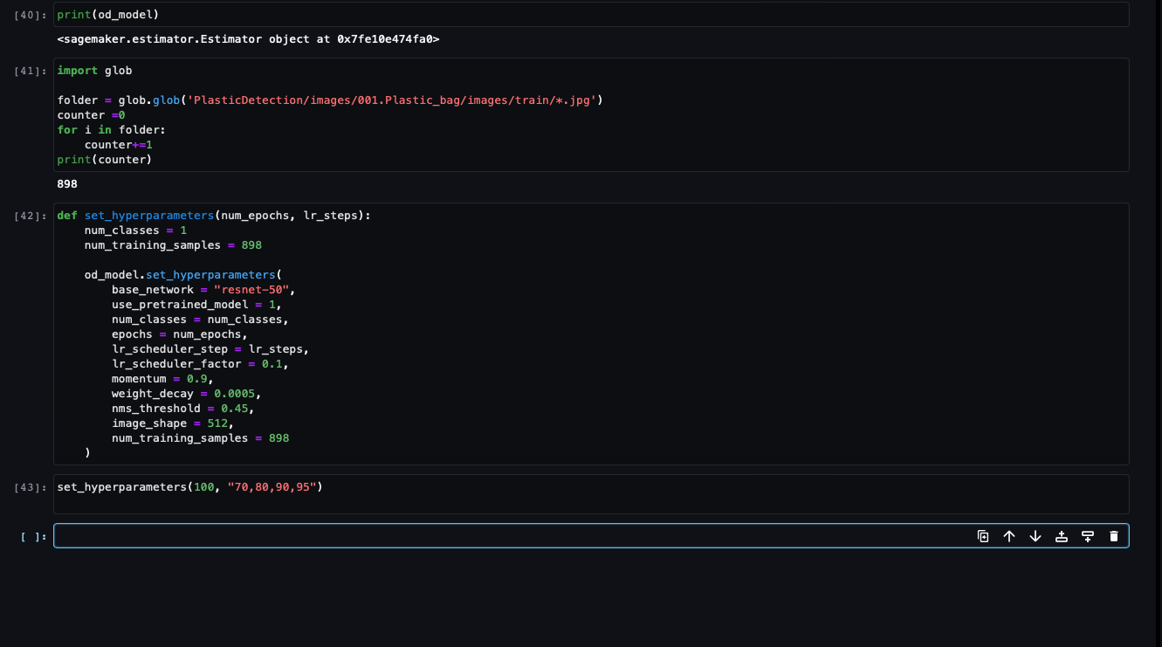

Hyperparameter tuning –

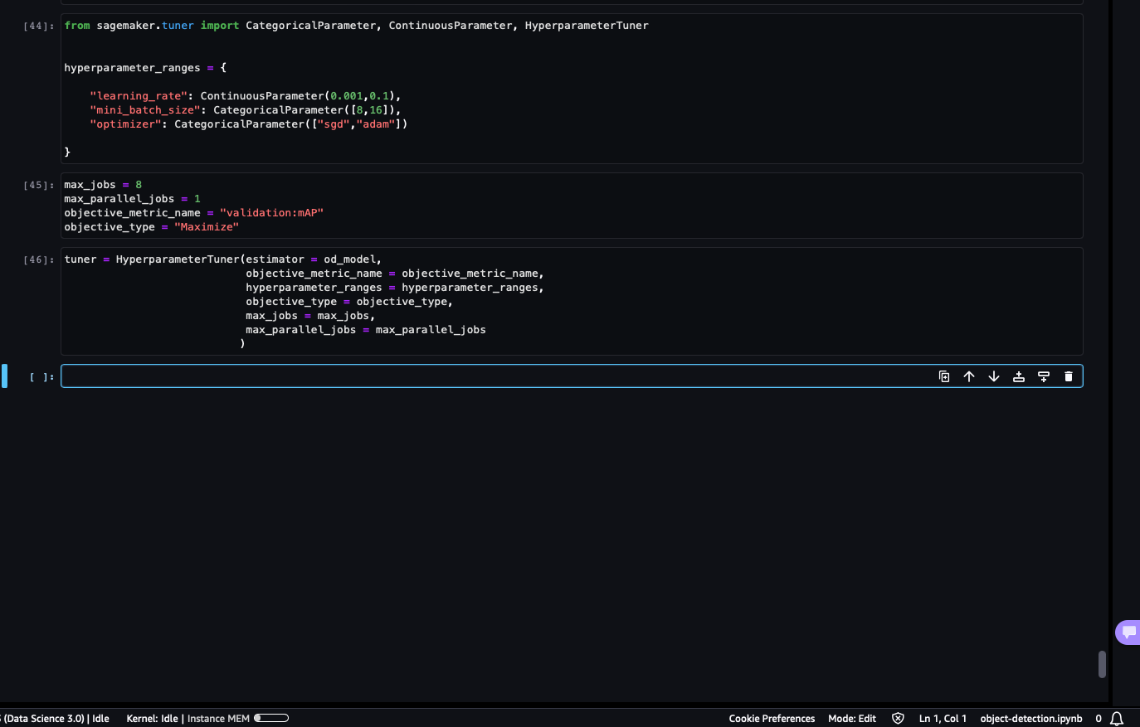

Starting the training Job –

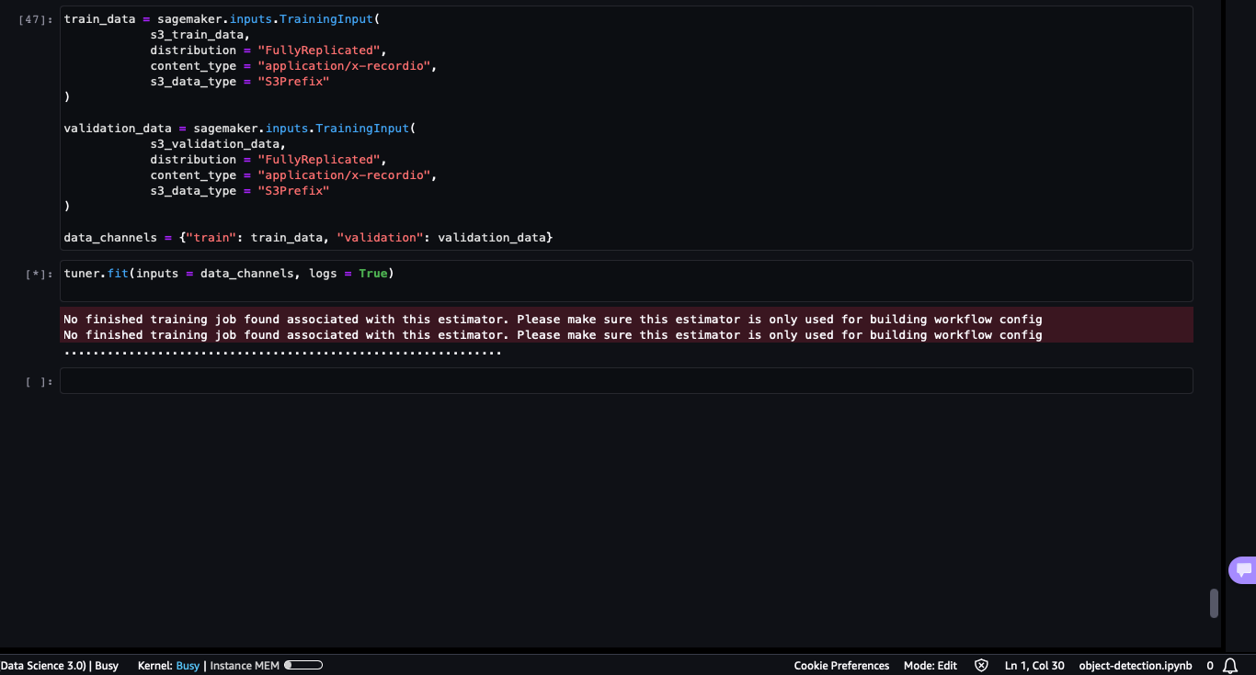

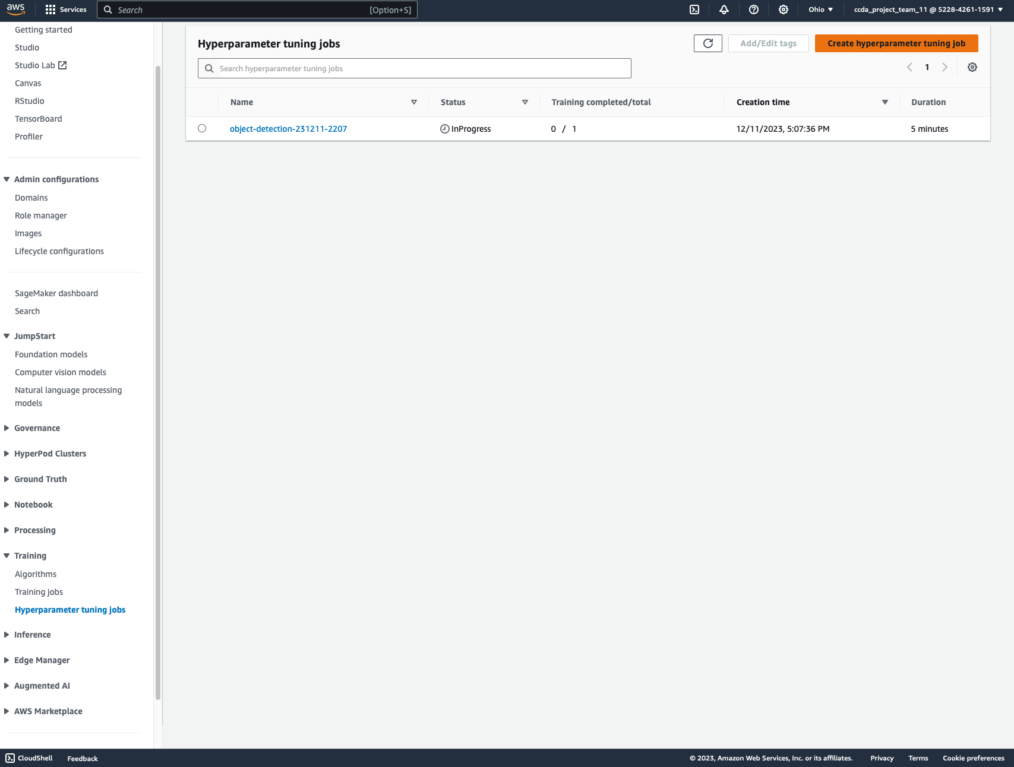

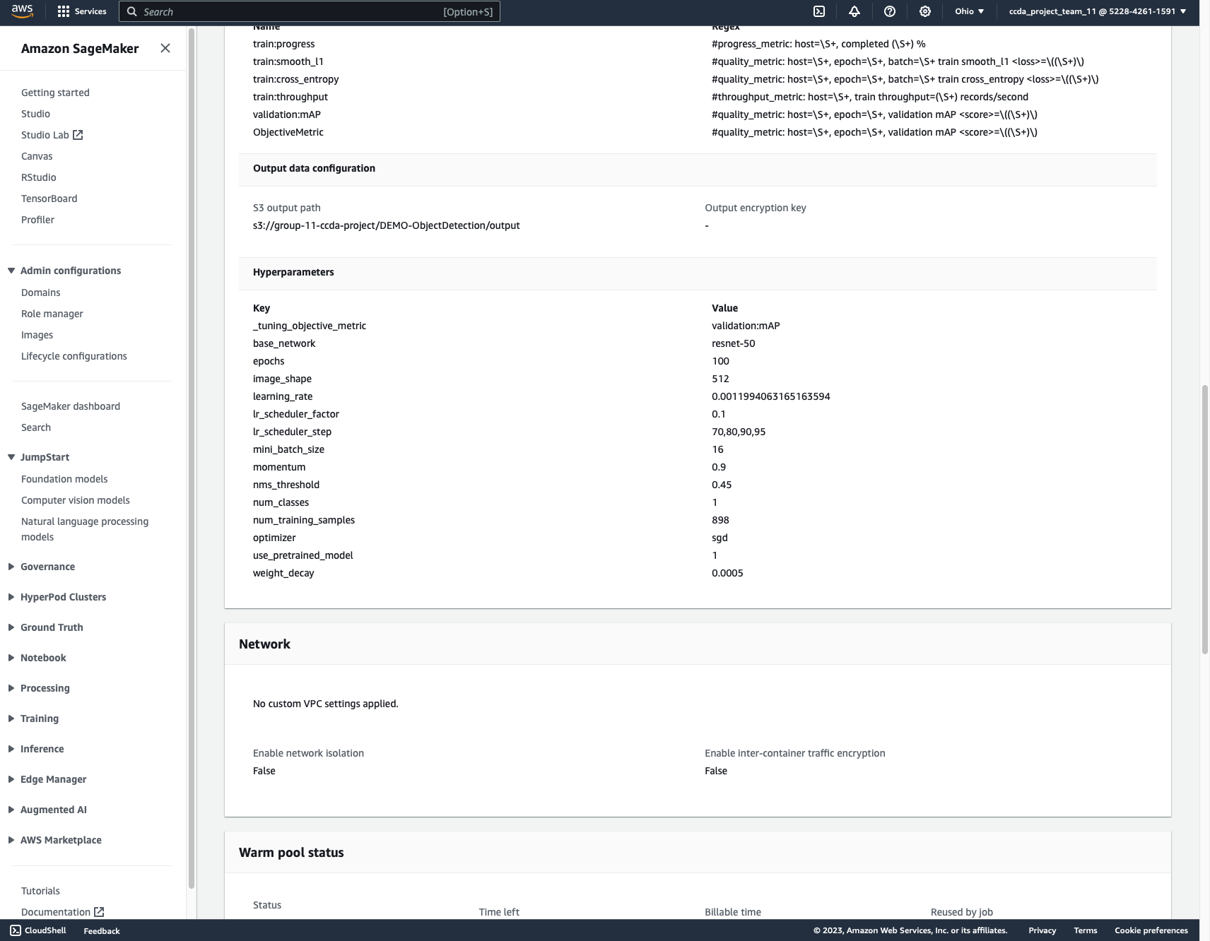

Training and Monitoring of the training jobs –

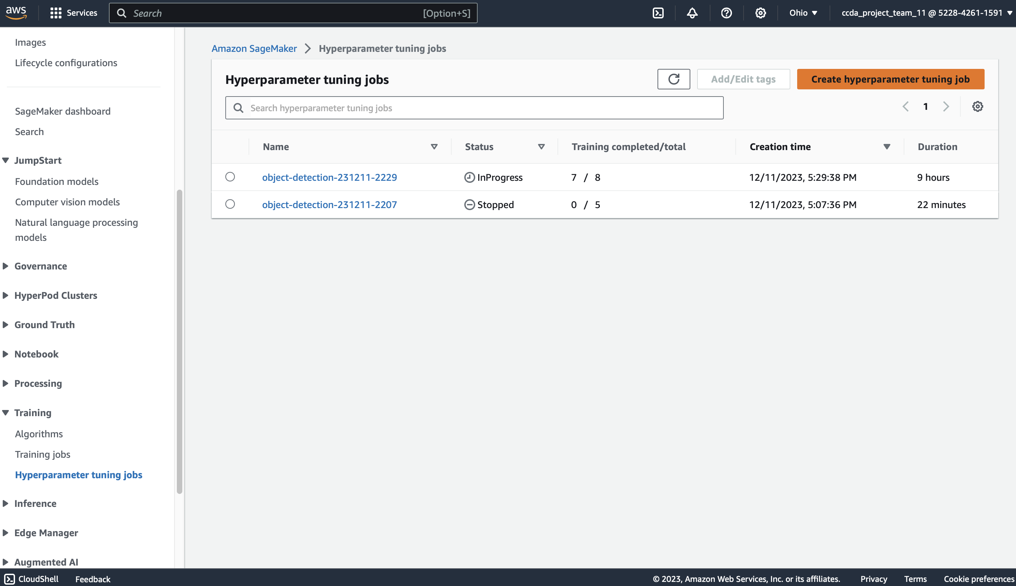

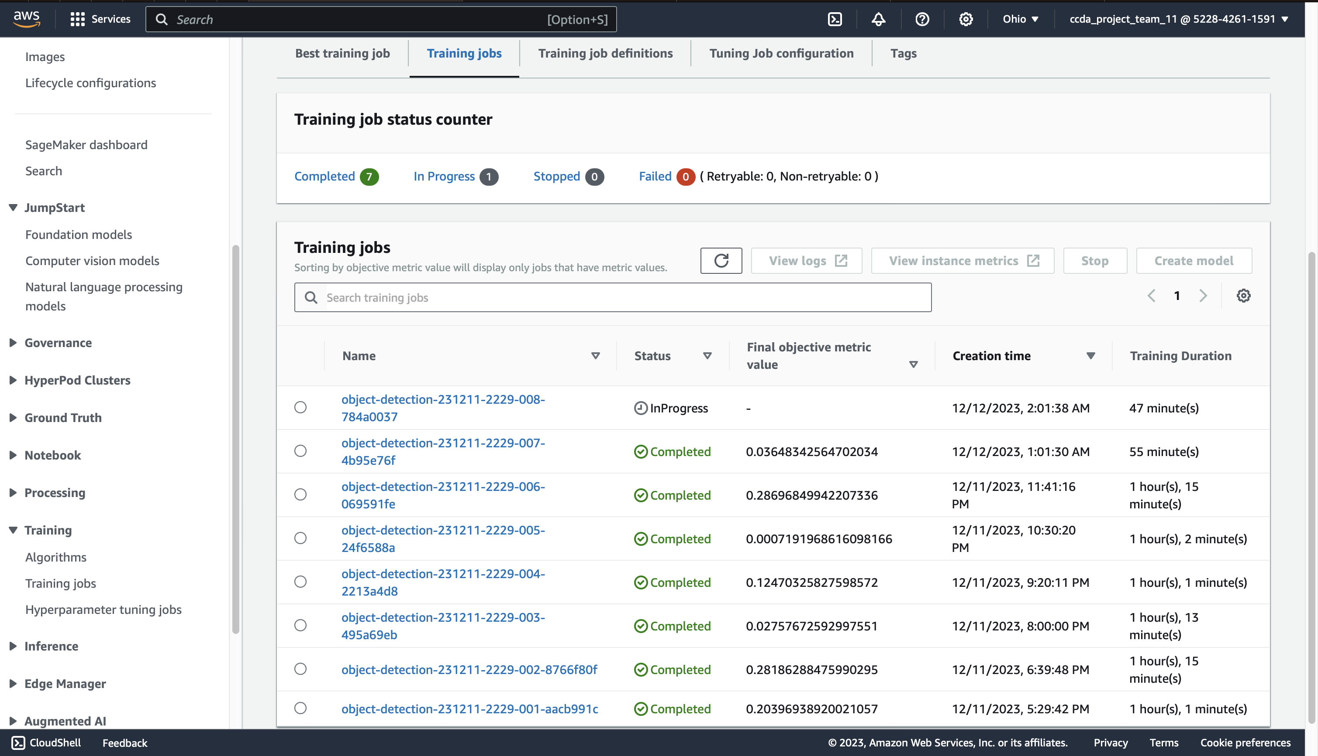

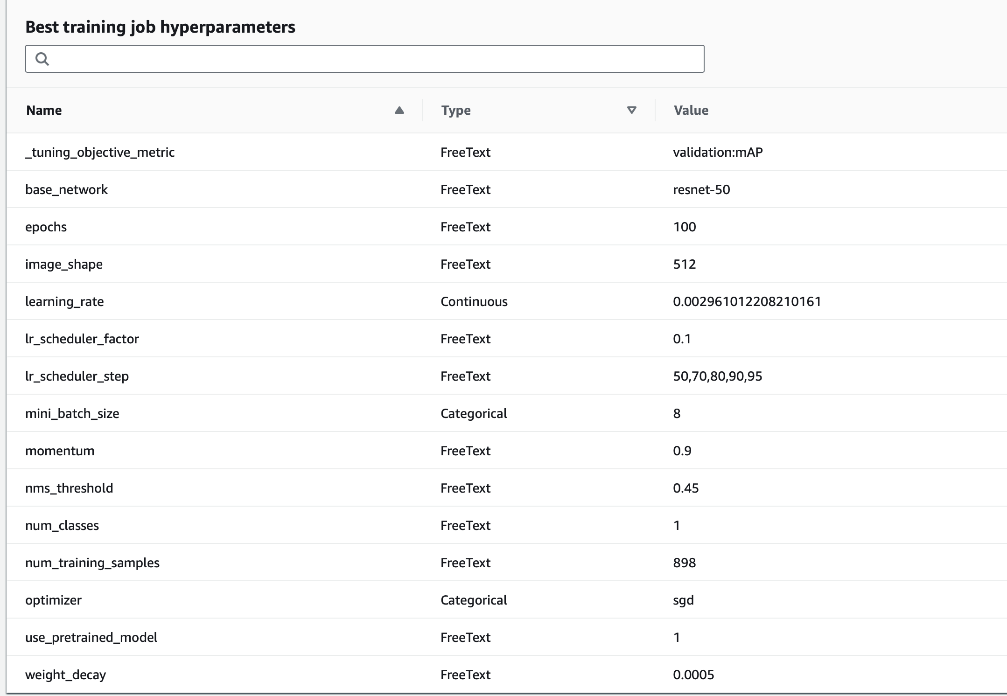

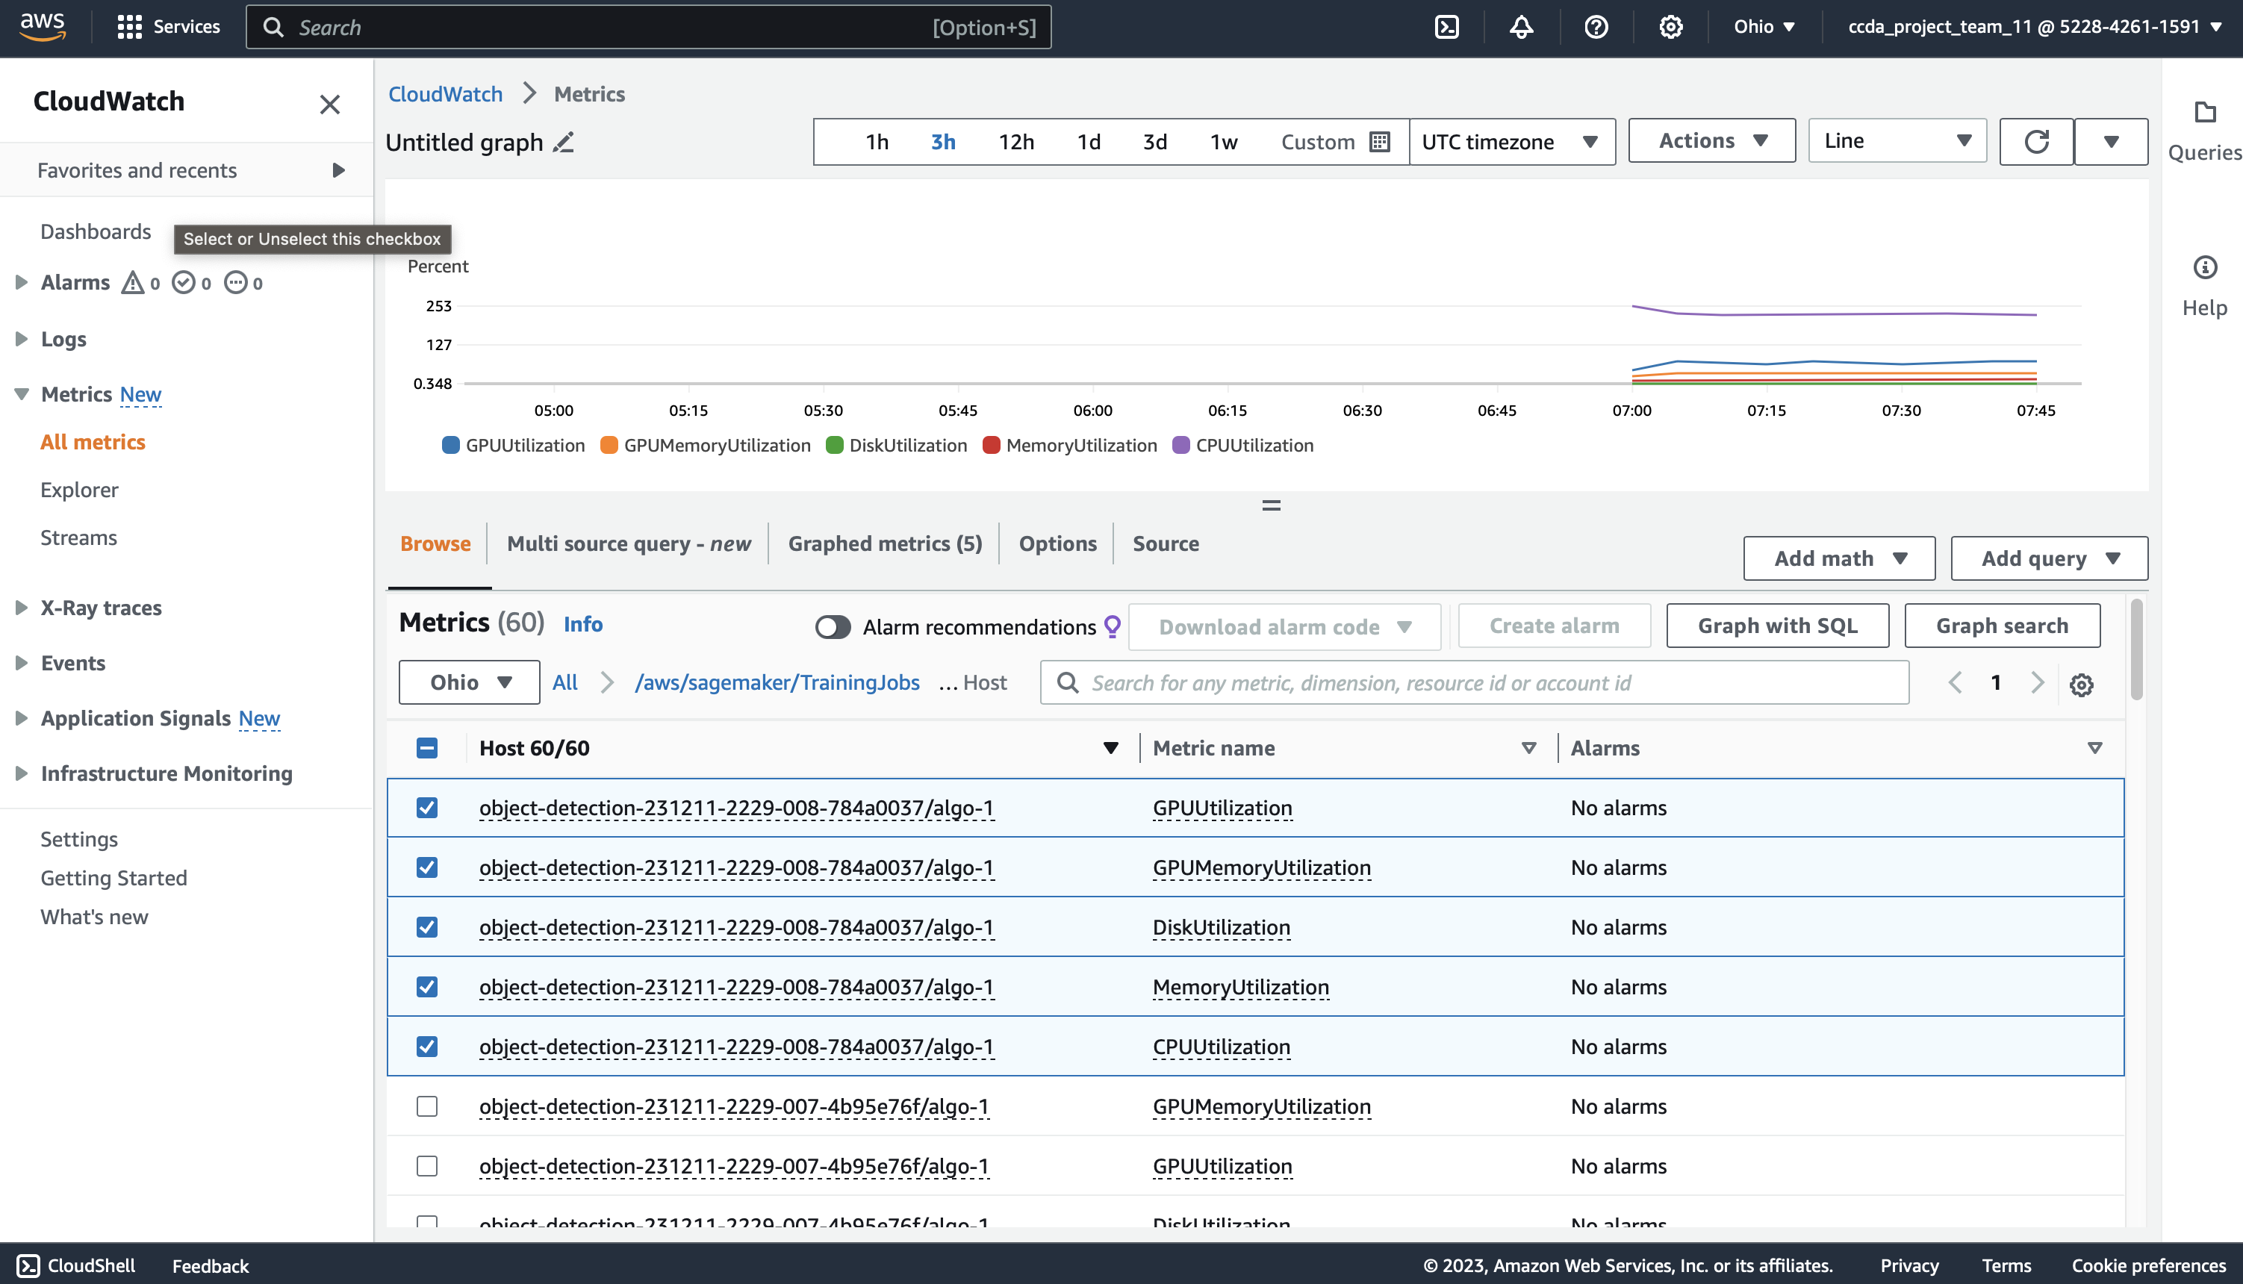

In S3 –

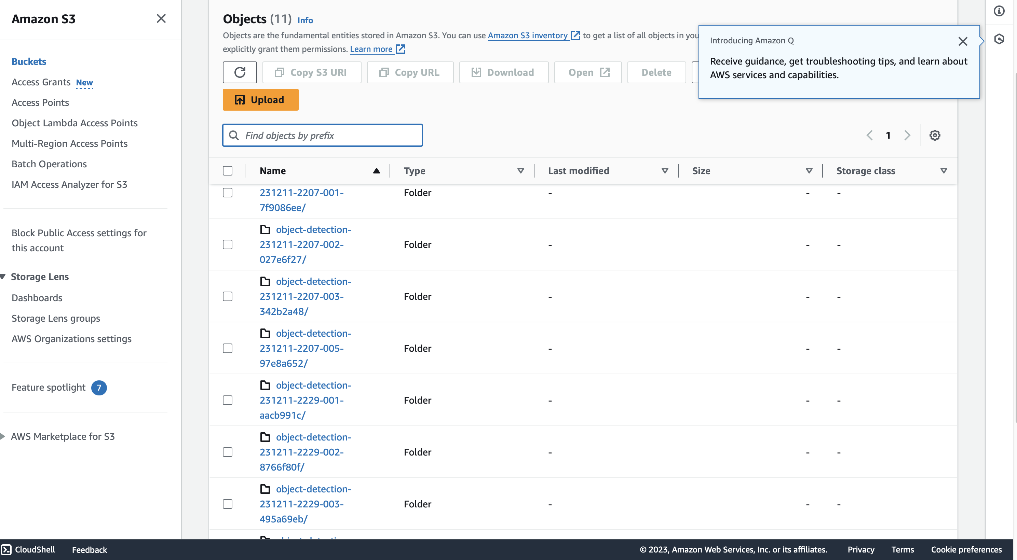

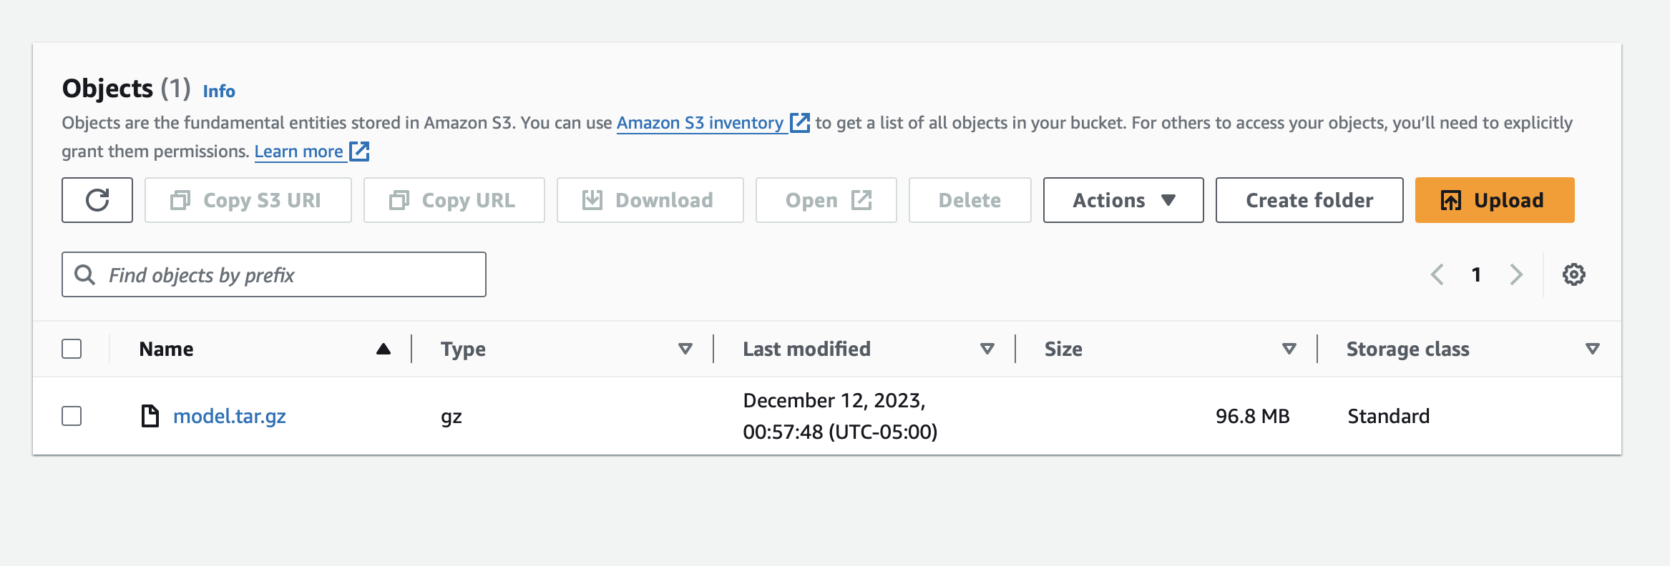

Deploying the model –

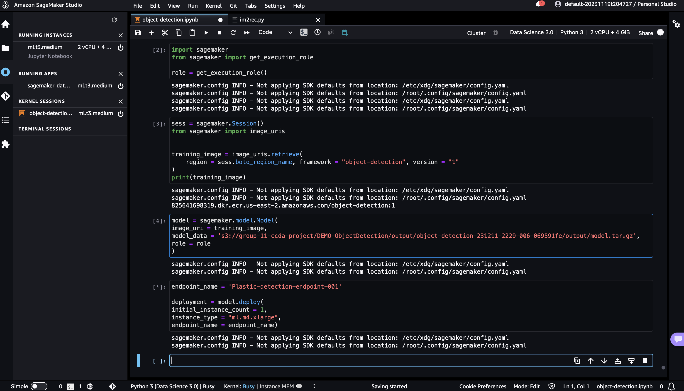

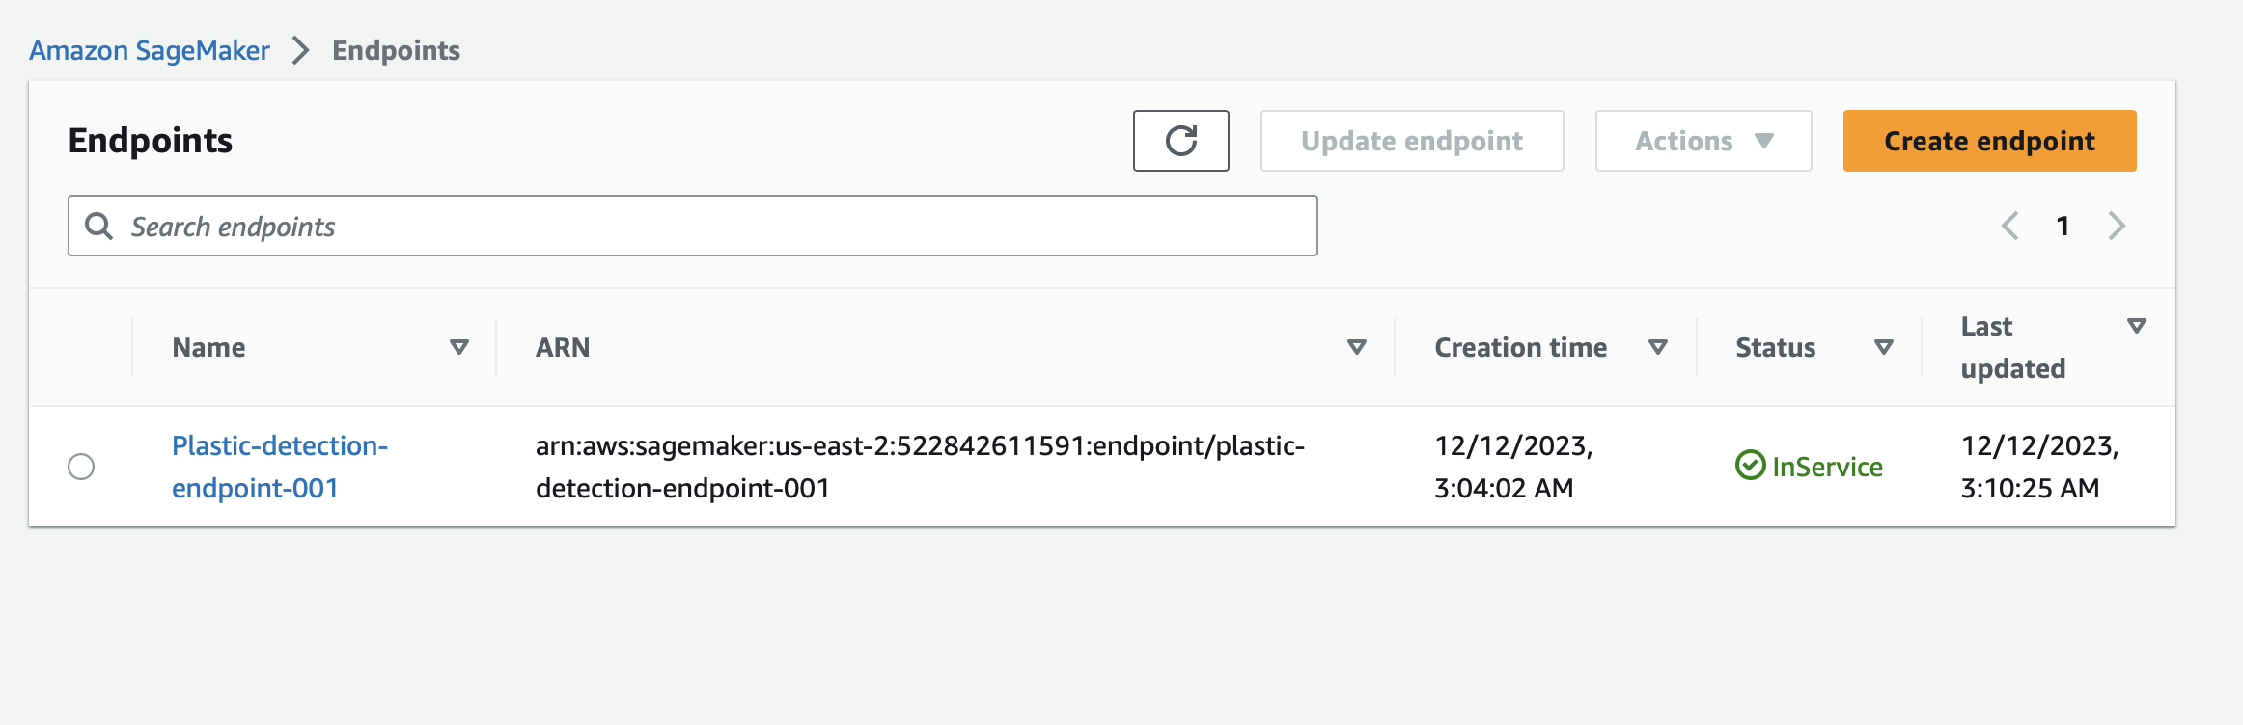

Testing the model –

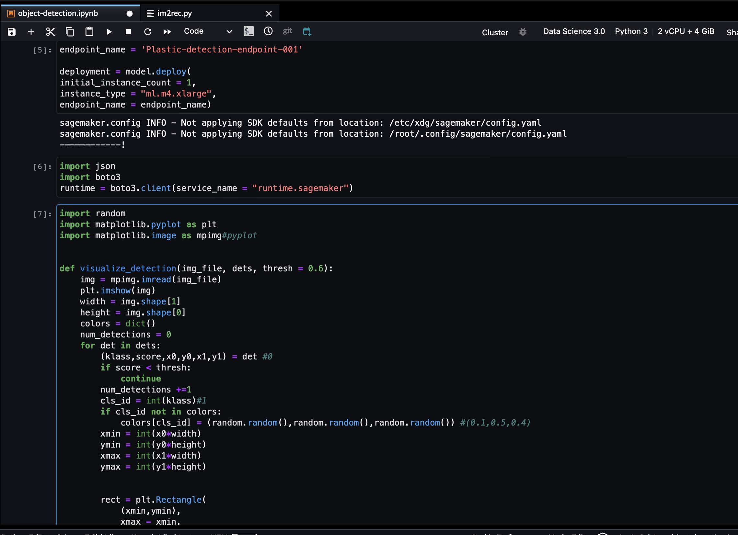

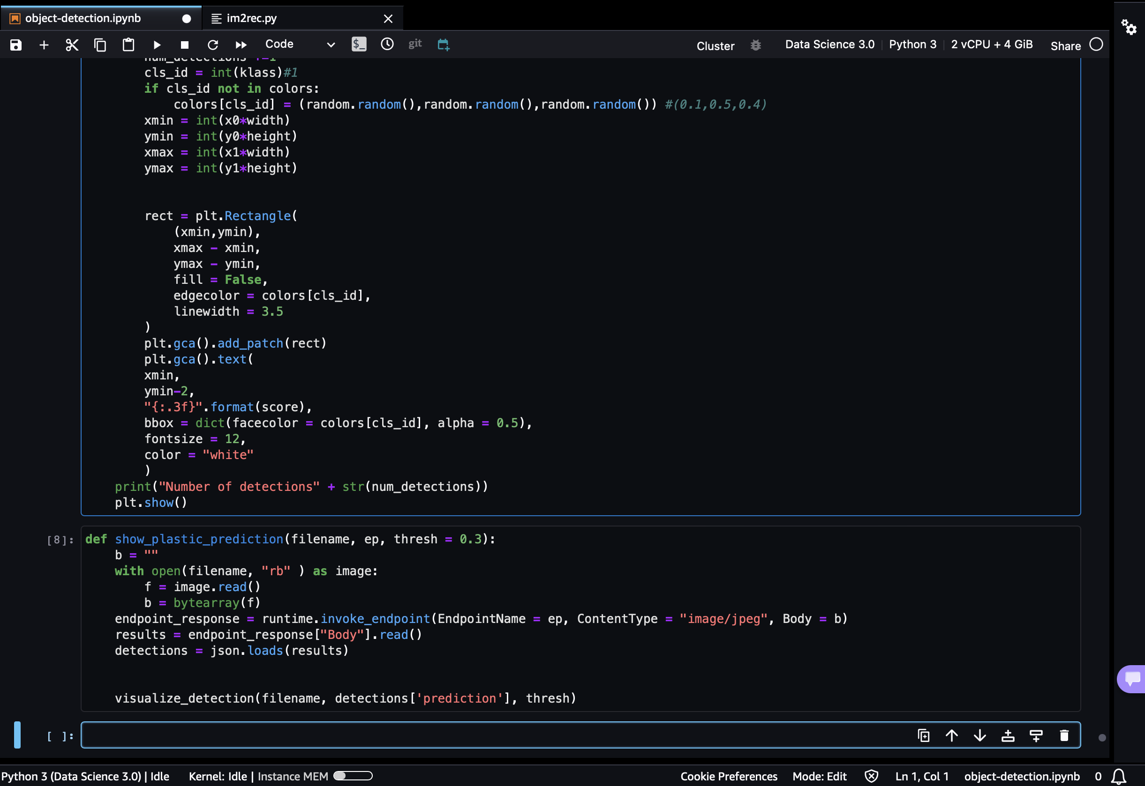

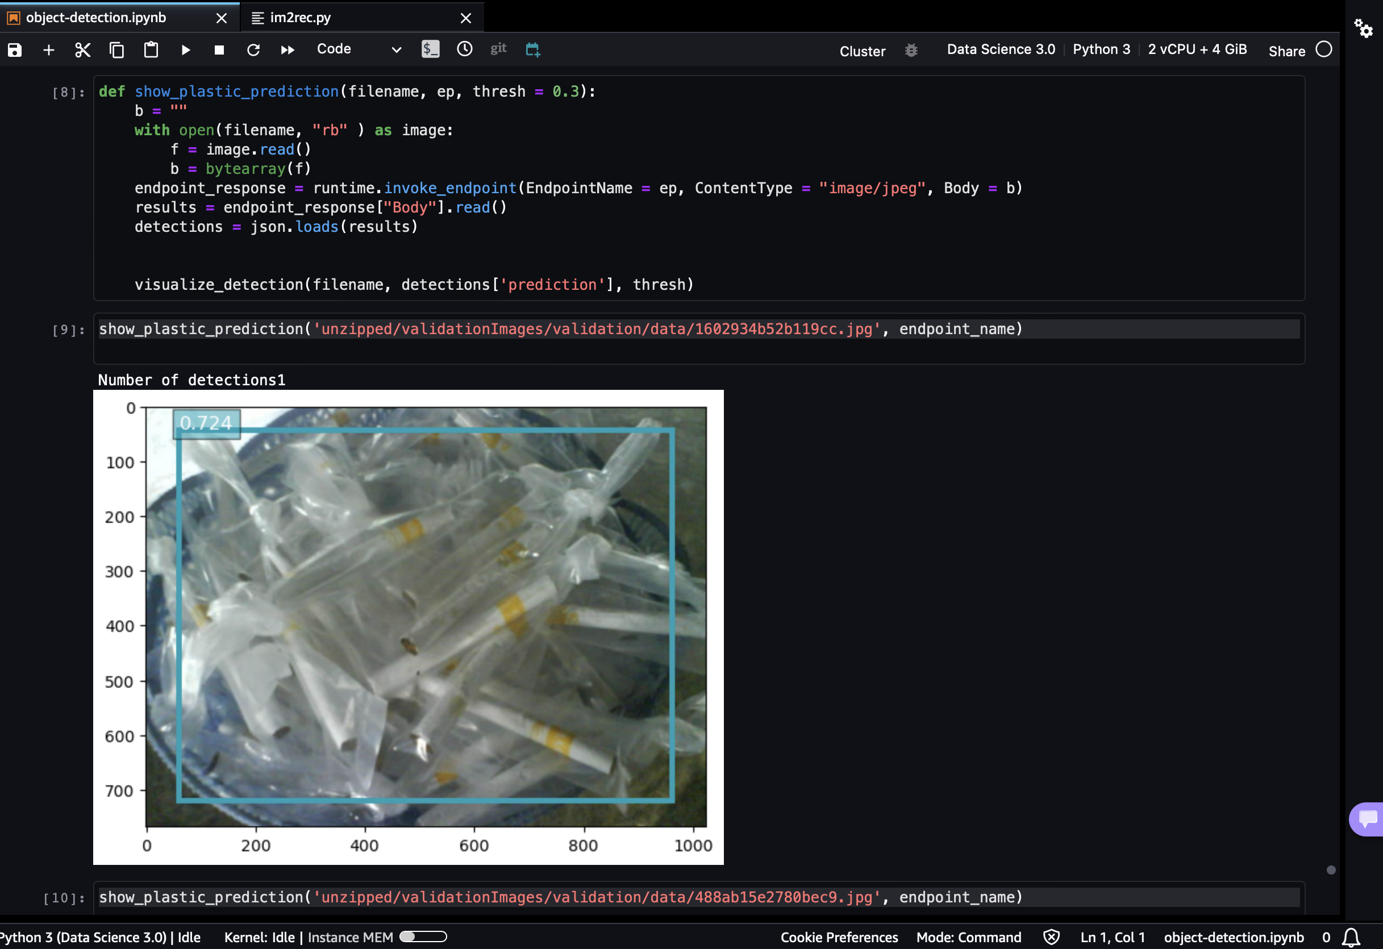

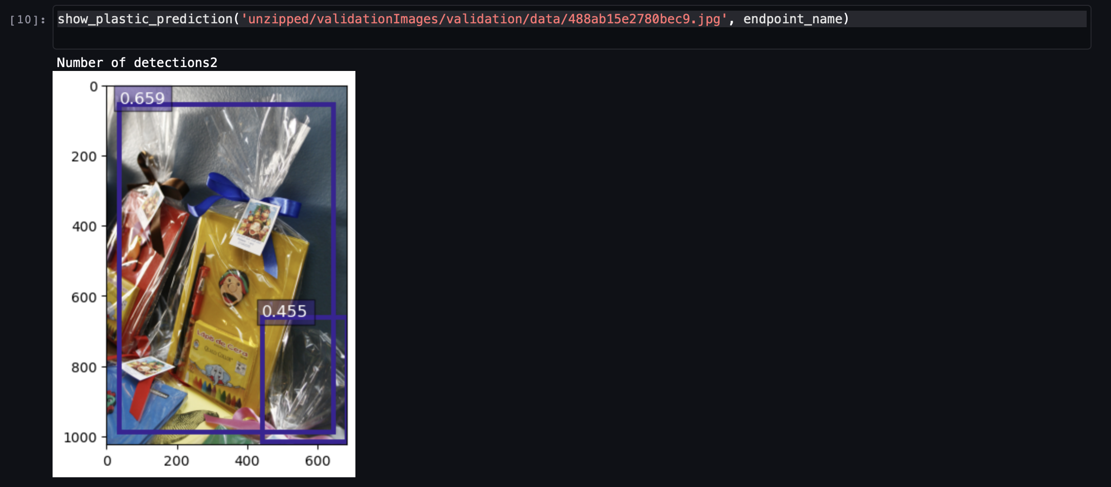

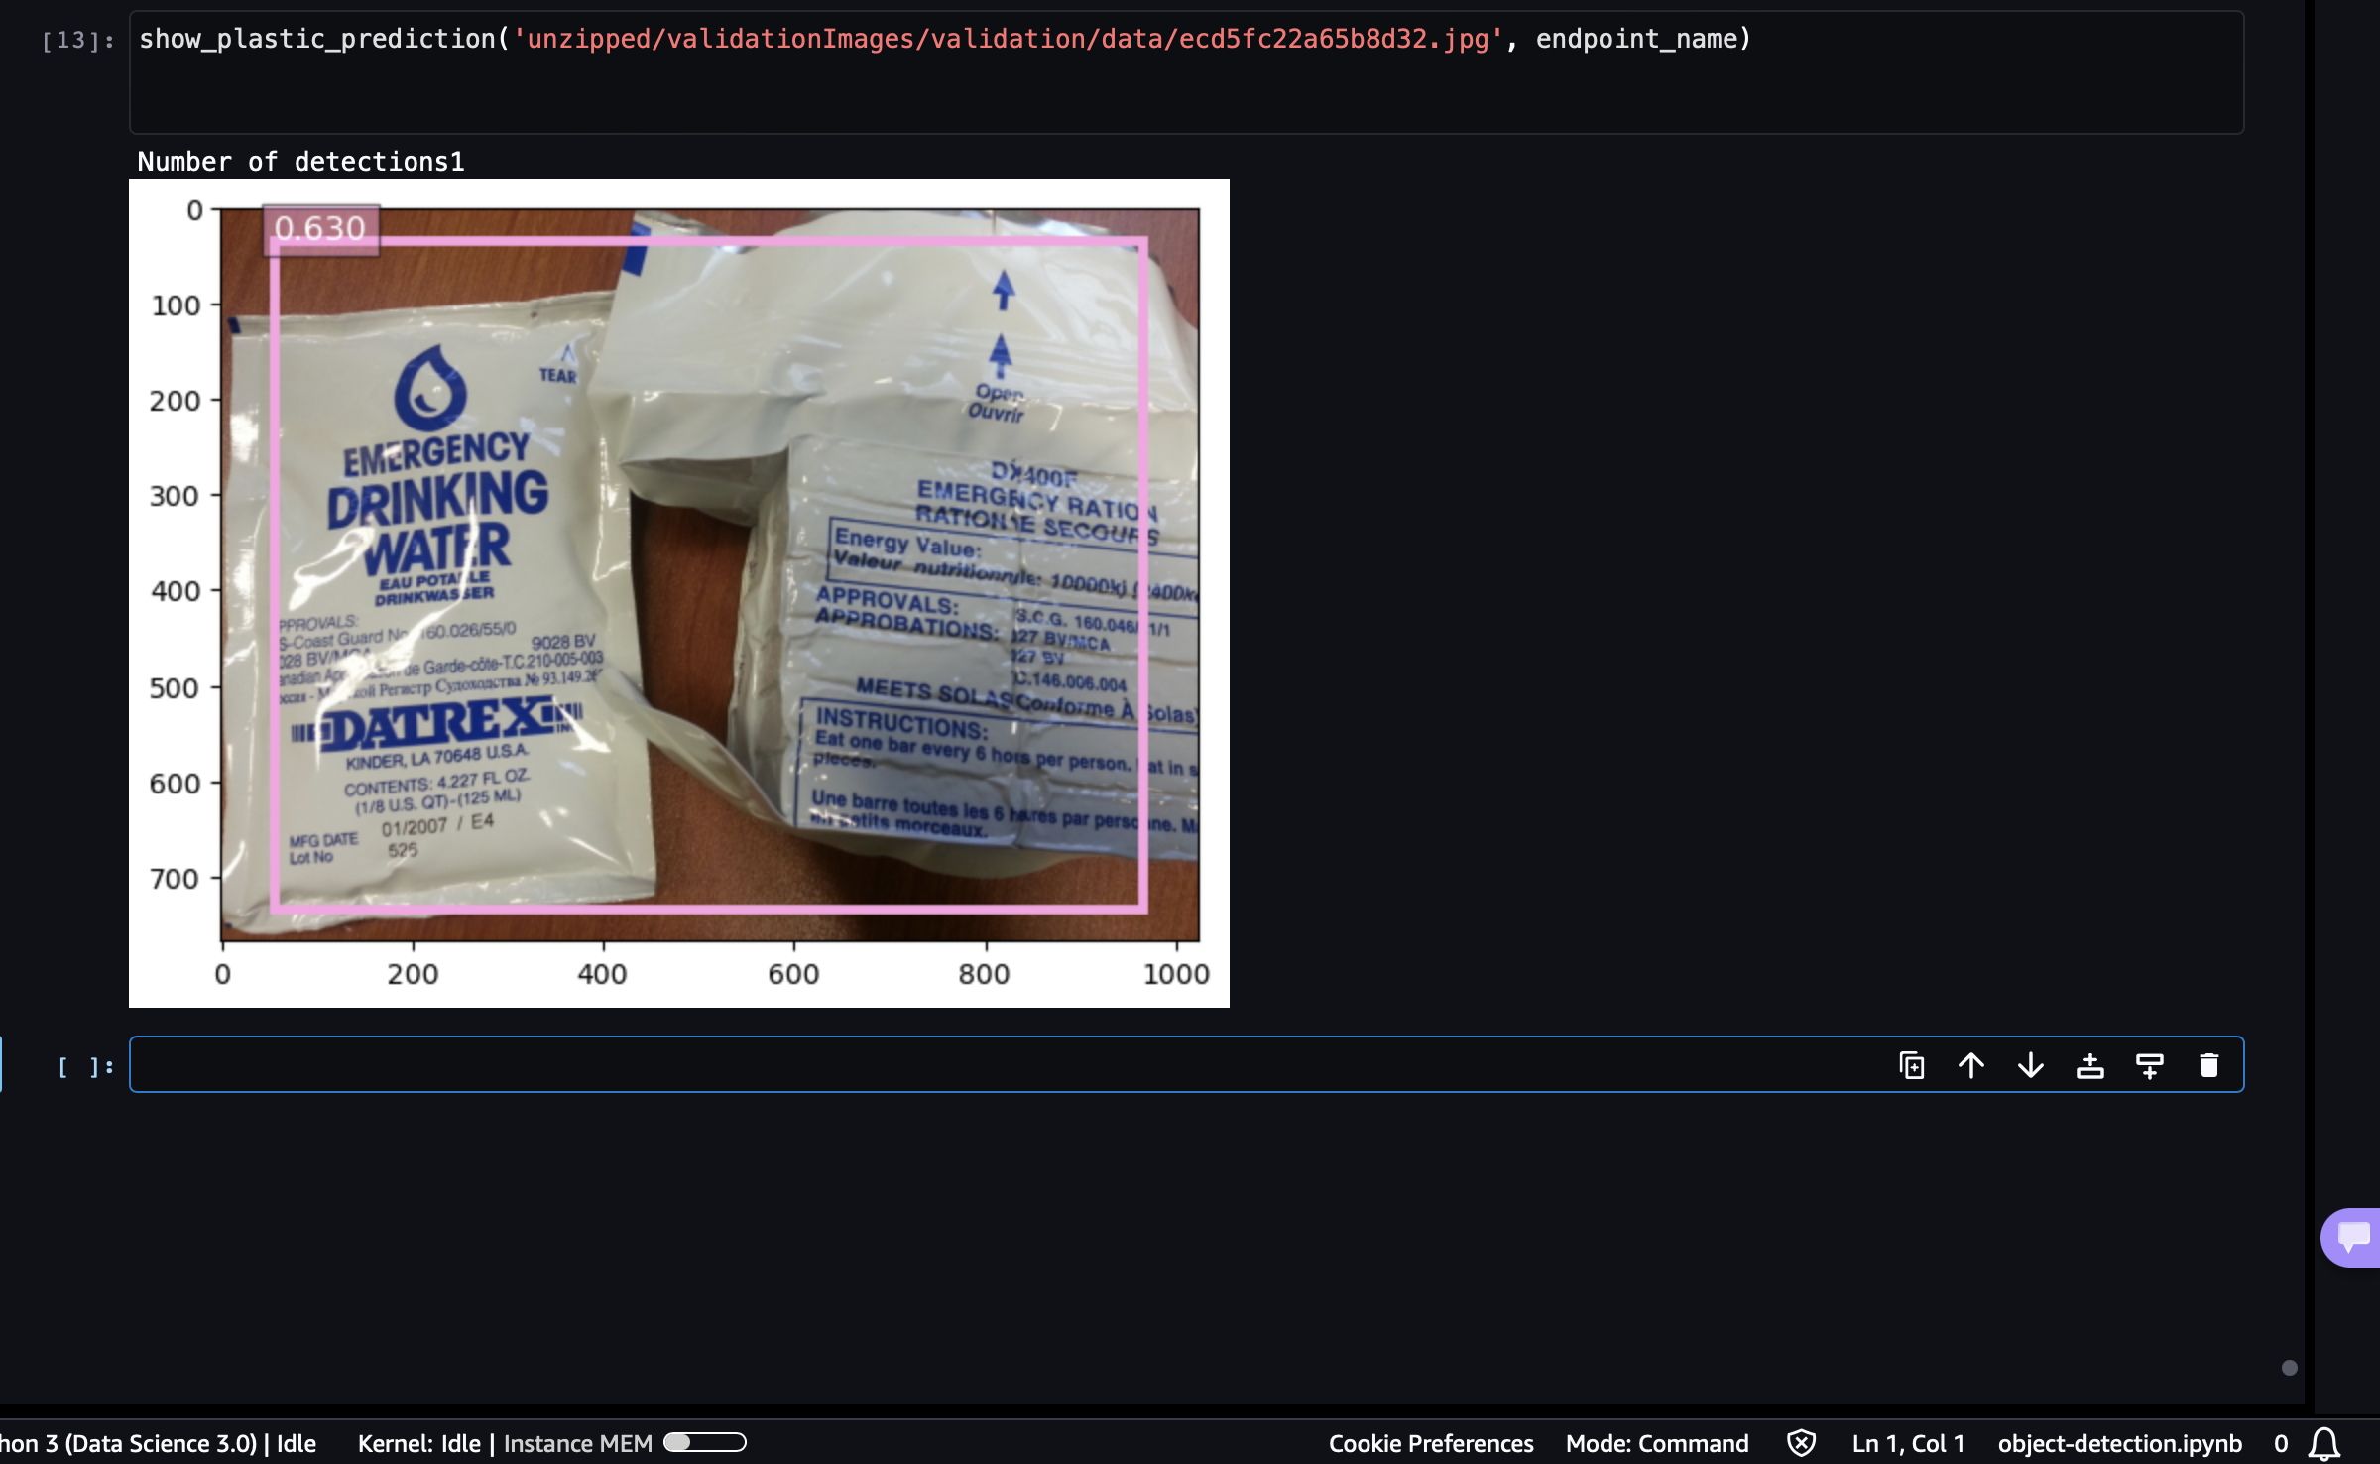

Cost Optimization –

All the services used in for this project are basic models that cost around 0.03 to 0.3$ per hour, with our estimations around 10$ for both storage costs and running inferences in endpoints and training.